**Name**: Khushei Meghana Meda

**SRN**: PES1201800416

**Week number**: 4

**Name of experiment**: Implementation of a Local DNS Server

**Date**: 30-09-2020

**Objectives of the experiment**: The objectives of this lab are to understand:

• DNS and how it works

• Install and set up a DNS server

• Functionality and operations

**Lab Setup**

DNS Server: 10.0.2.15 User/Client: 10.0.2.4

Server:

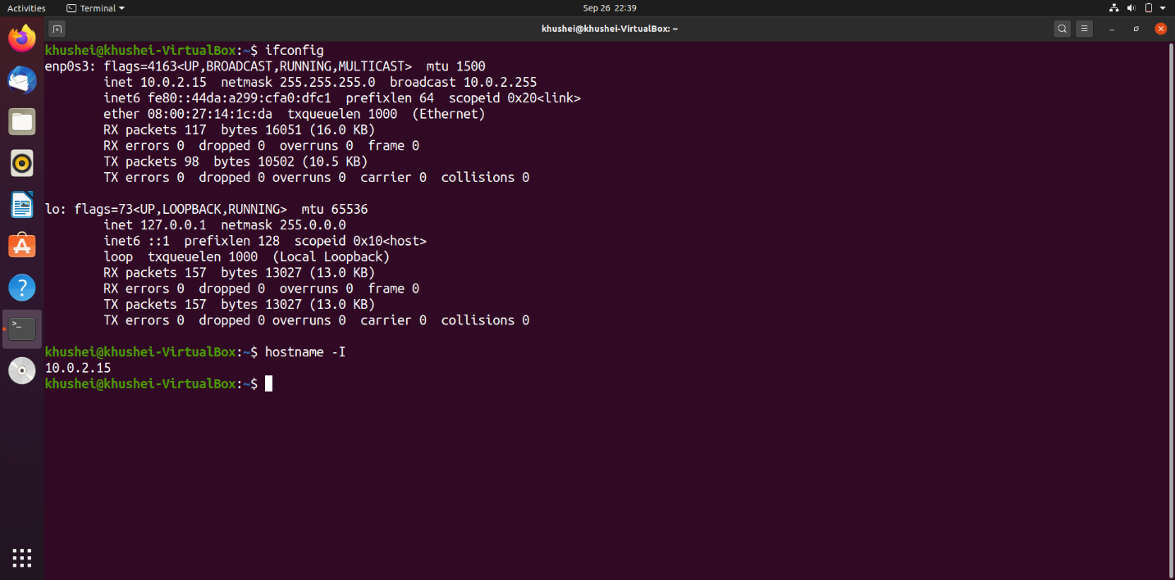

Client:

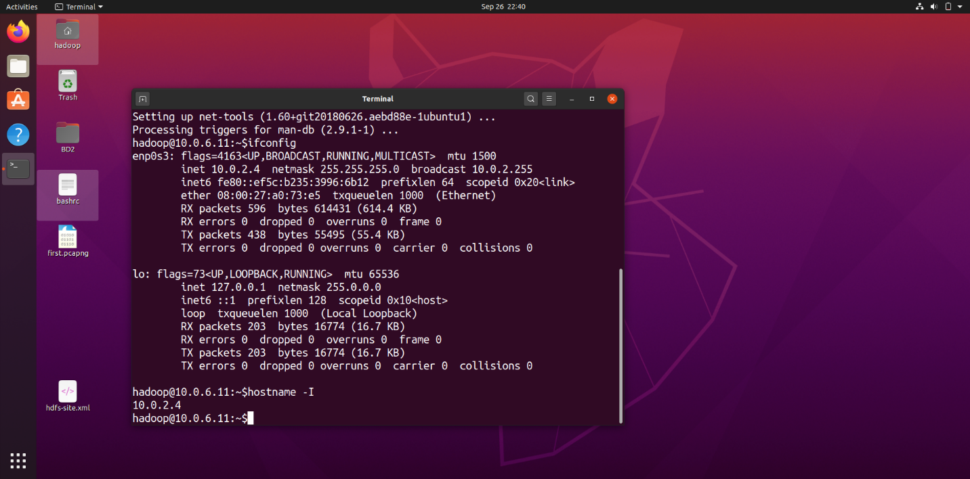

**First Test:**

Queries-

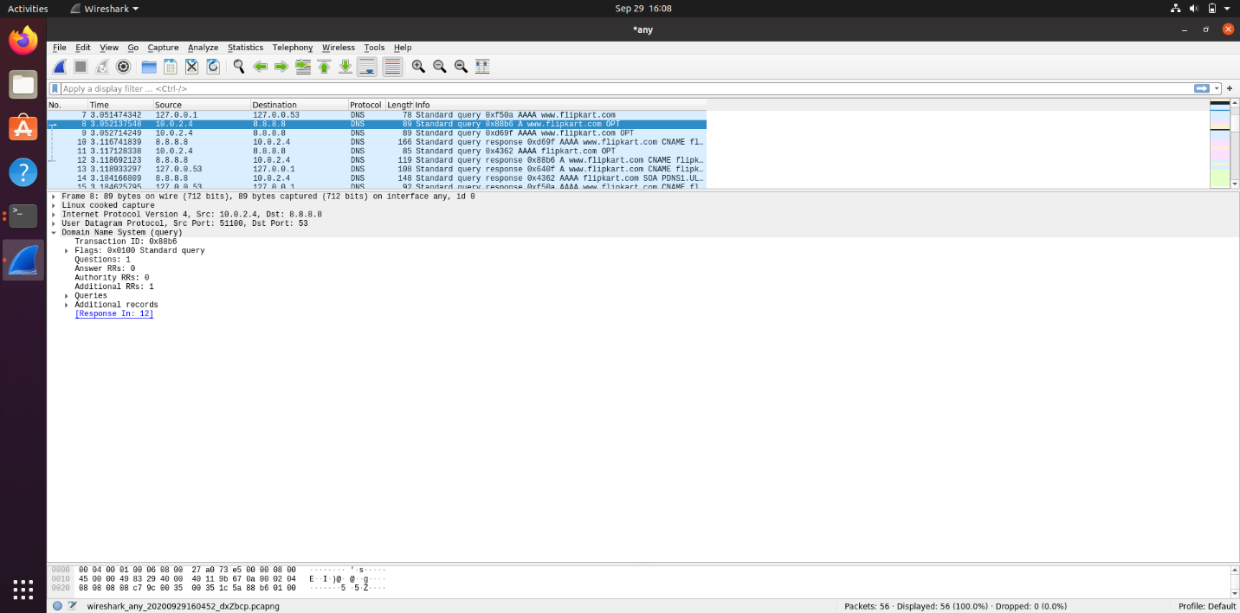

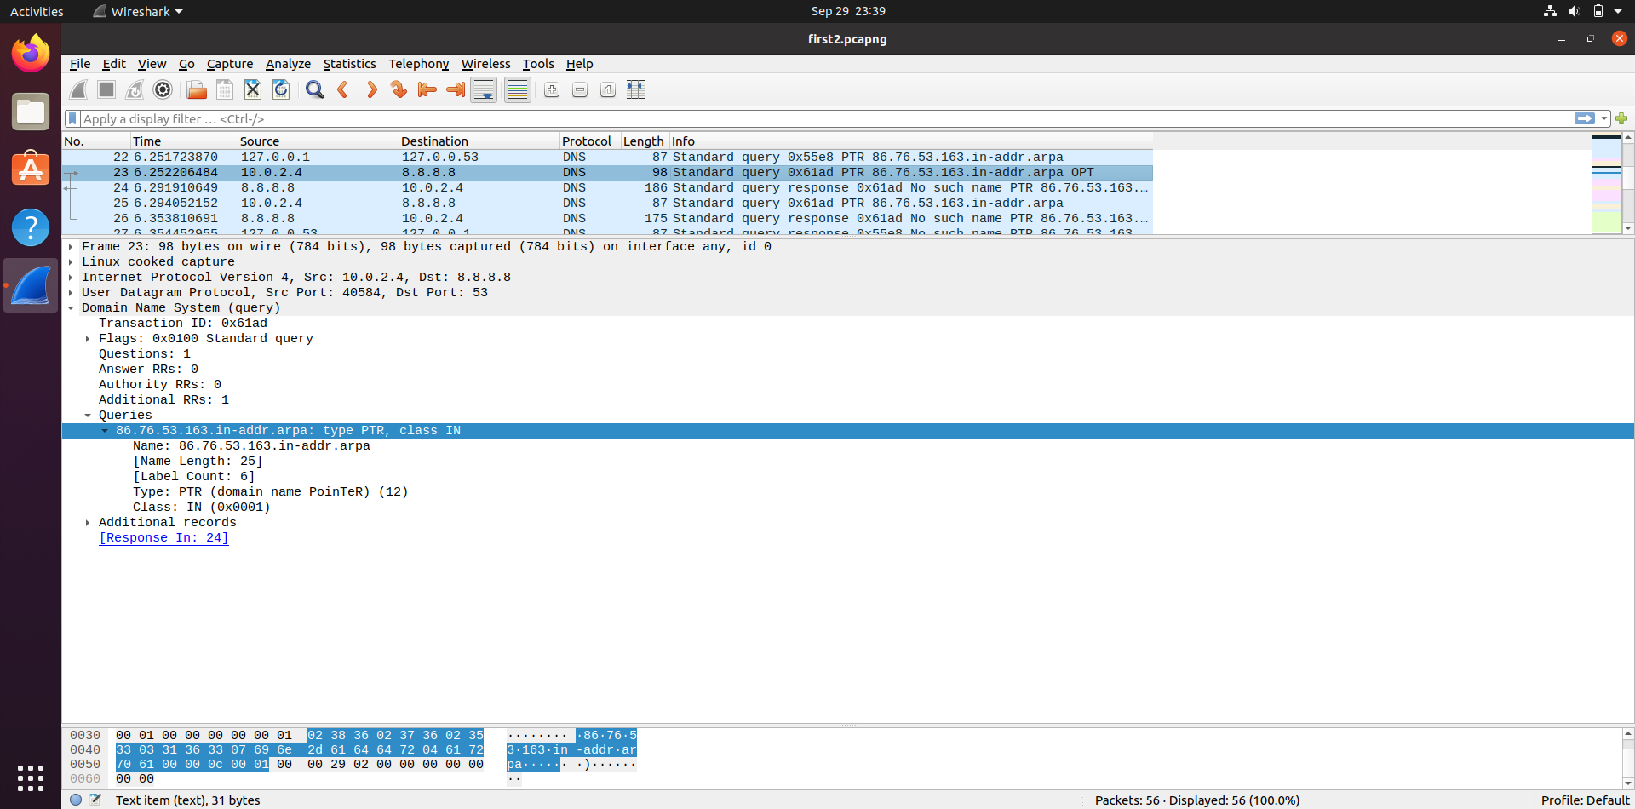

Responses-

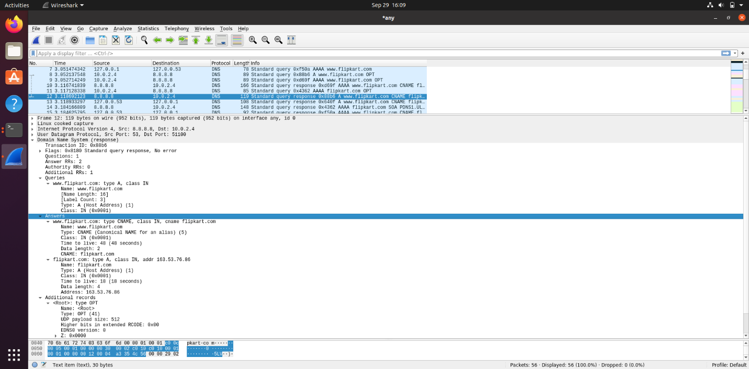

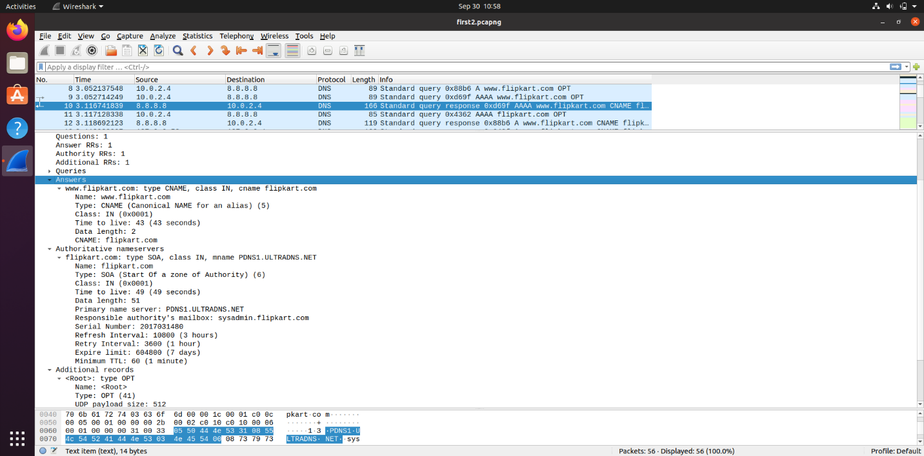

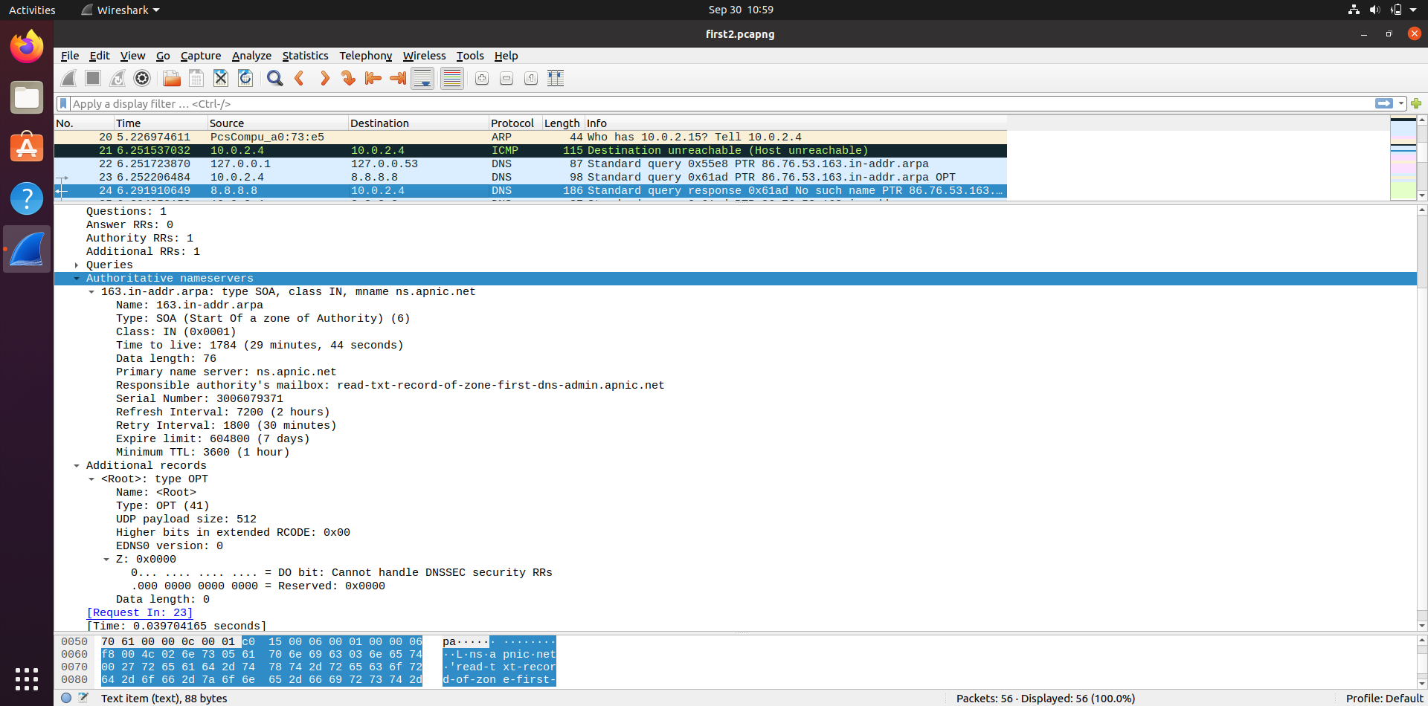

Observation: The ping request is resolved by first requesting the ISP; the DNS request created is A record, which requests TLD and that requests Authoritative Servers for the IP address.

1) Locate the DNS query and response messages. Are then sent over UDP or TCP?

They are sent over UDP.

2) What is the destination port for the DNS query message? What is the source port of DNS response message?

Destination Port for DNS query message: 53

Source Port for DNS response message: 53

3) To what IP address is the DNS query message sent? Use ipconfig to determine the IP address of your local DNS server. Are these two IP addresses the same?

The DNS query message is sent to 8.8.8.8. As we can see in the screenshot below, the IP address is present in the list of IP addresses for my local DNS server.

8.8.8.8 comes by default in the list of DNS for every connection that is already created or I create on my own.

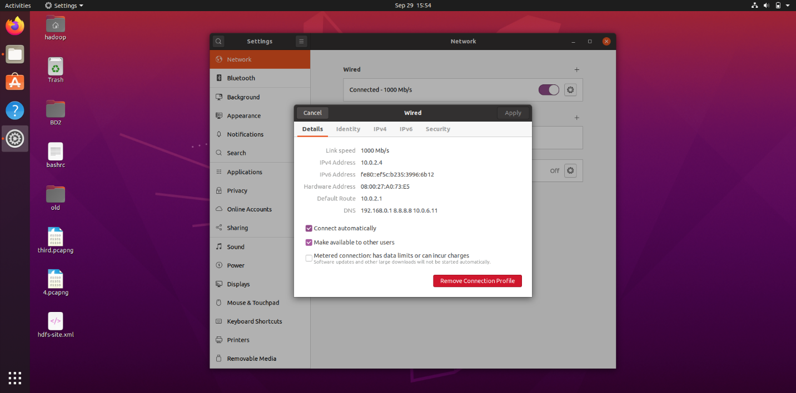

4) Examine the DNS query message. What “Type” of DNS query is it? Does the query message contain any “answers”?

The query highlighted in the first screenshot is a Type A Standard Query which stores hostname and its corresponding IPv4 address.

Below that we can also see Type AAAA Standard Query which stores hostname and its corresponding IPv6 address.

In the second screenshot, we can also see one PTR query message that resolves an IP address to a domain or host name, unlike an A record which points a domain name to an IP address.

The query messages do not contain any answers.

5) Examine the DNS response message. How many “answers” are provided? What do each of these answers contain?

2 answers are provided in the response message for the A type query. The answers contain name of the host, type of the address, class, TTL, data length. The first answer has CNAME (has the canonical name of [www.flipkart.com](http://www.flipkart.com) as flipkart.com) in the end and the second answer has the IP address.

Answers

www.flipkart.com: type CNAME, class IN, cname flipkart.com

Name: www.flipkart.com

Type: CNAME (Canonical NAME for an alias) (5)

Class: IN (0x0001)

Time to live: 48 (48 seconds)

Data length: 2

CNAME: flipkart.com

flipkart.com: type A, class IN, addr 163.53.76.86

Name: flipkart.com

Type: A (Host Address) (1)

Class: IN (0x0001)

Time to live: 18 (18 seconds)

Data length: 4

Address: 163.53.76.86

1 answer is provided in the response message for the AAAA type query. It has a CNAME record.

Answers

www.flipkart.com: type CNAME, class IN, cname flipkart.com

Name: www.flipkart.com

Type: CNAME (Canonical NAME for an alias) (5)

Class: IN (0x0001)

Time to live: 43 (43 seconds)

Data length: 2

CNAME: flipkart.com

0 answers are provided for the PTR type query.

6) Consider the subsequent TCP SYN packet sent by your host. Does the destination IP address of the SYN packet correspond to any of the IP addresses provided in the DNS response message?

No, the destination IP address of the SYN packet does not correspond to any of the IP addresses provided in the DNS response message. I get the IP address as 35.224.99.156 which is of Google Cloud.

[Note: As I understand, I was supposed to get an IP address that was returned in the Answers section of the DNS response. However, despite trying three-four times this is what I got.]

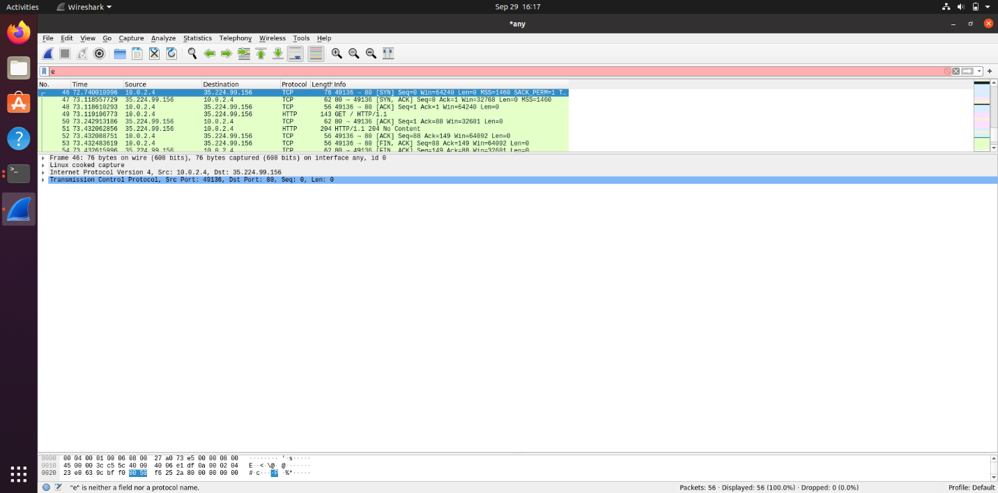

**Task 1: Configure the User Machine**

**Second Test:**

Queries-

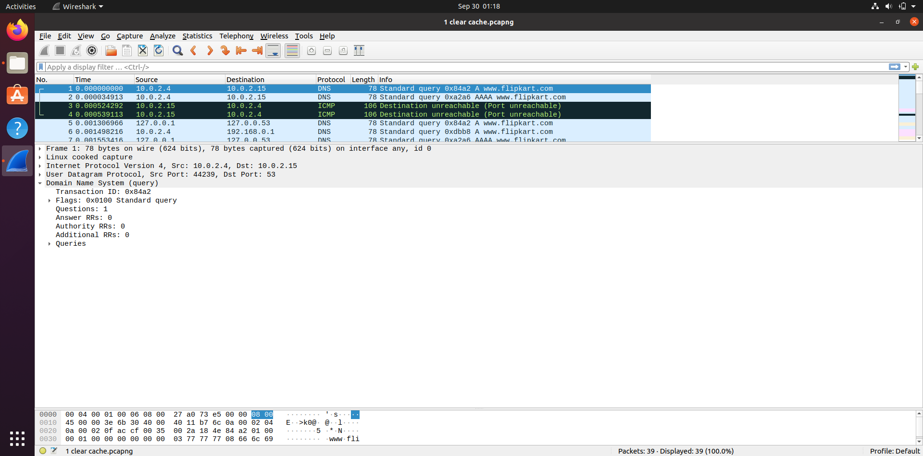

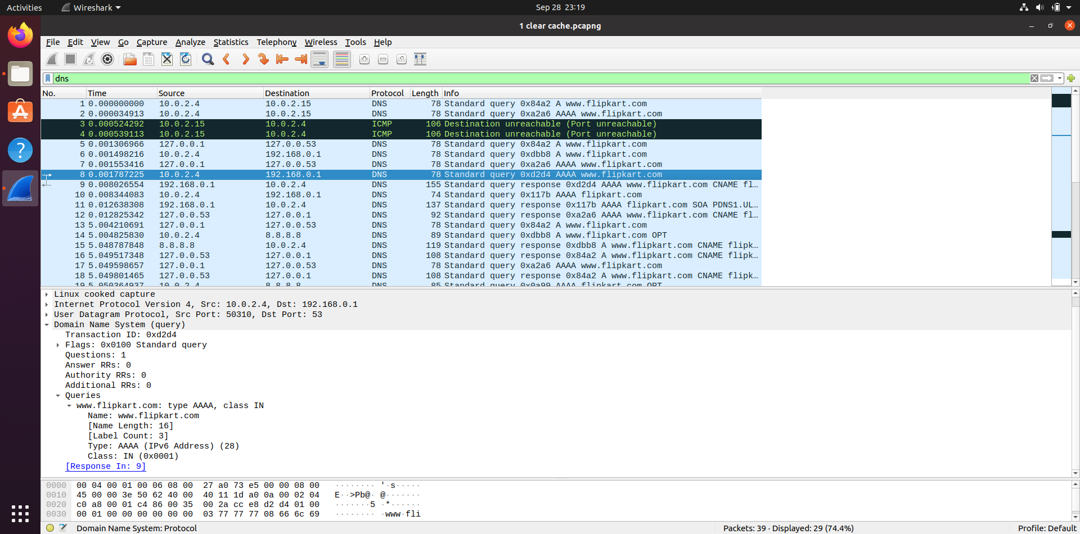

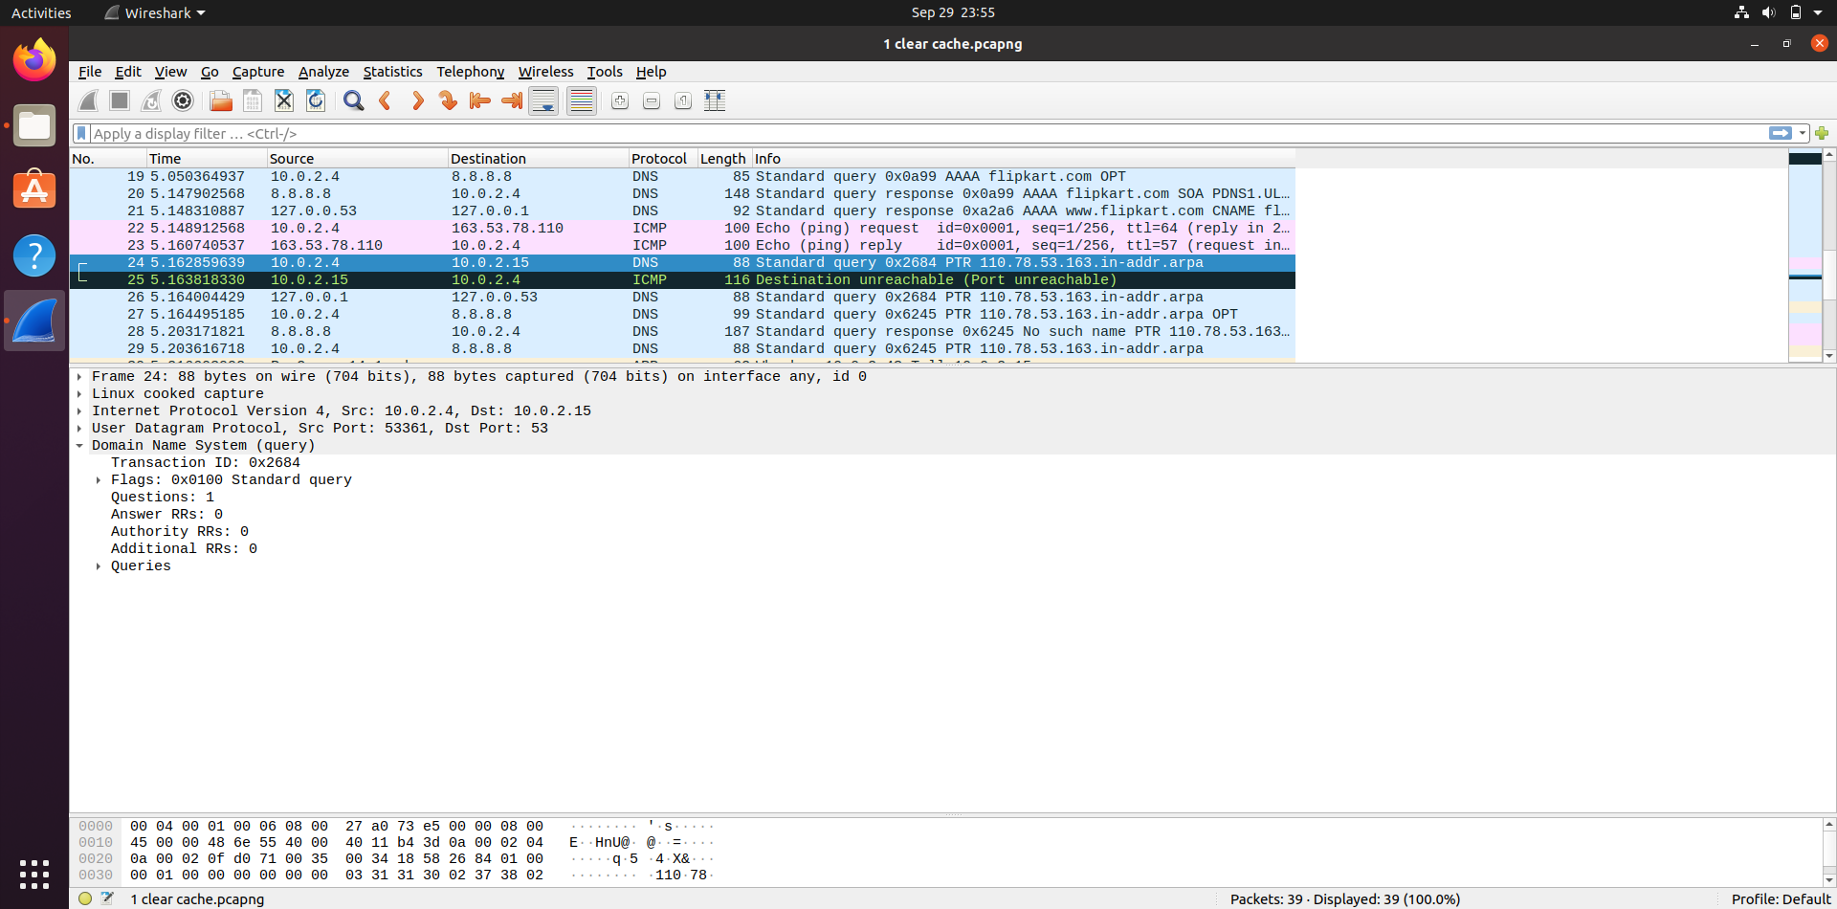

Responses-

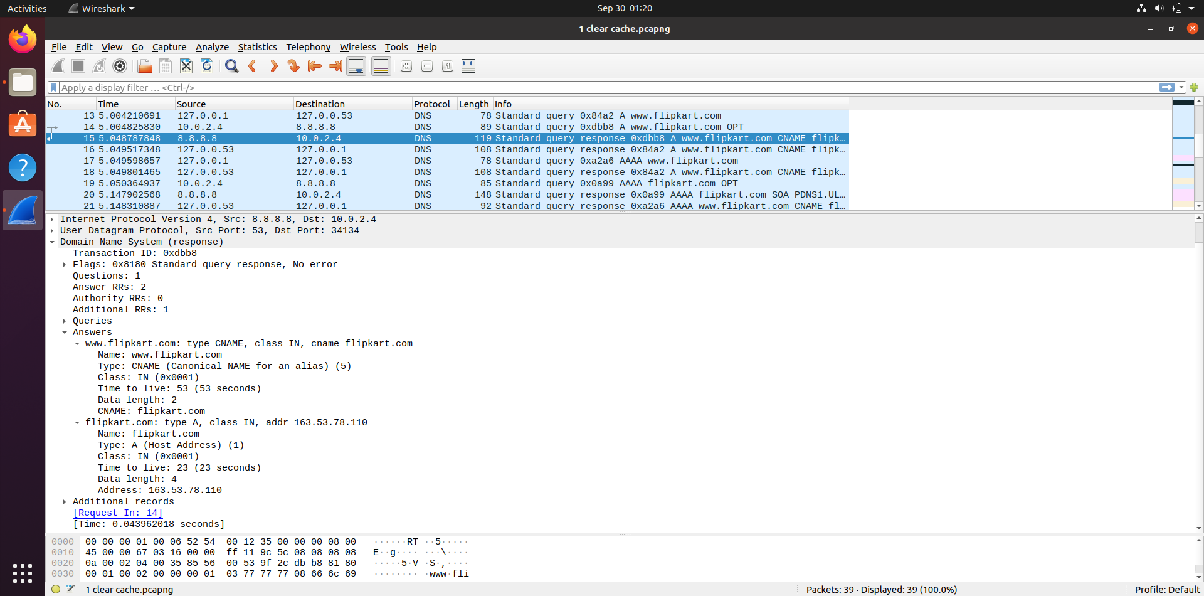

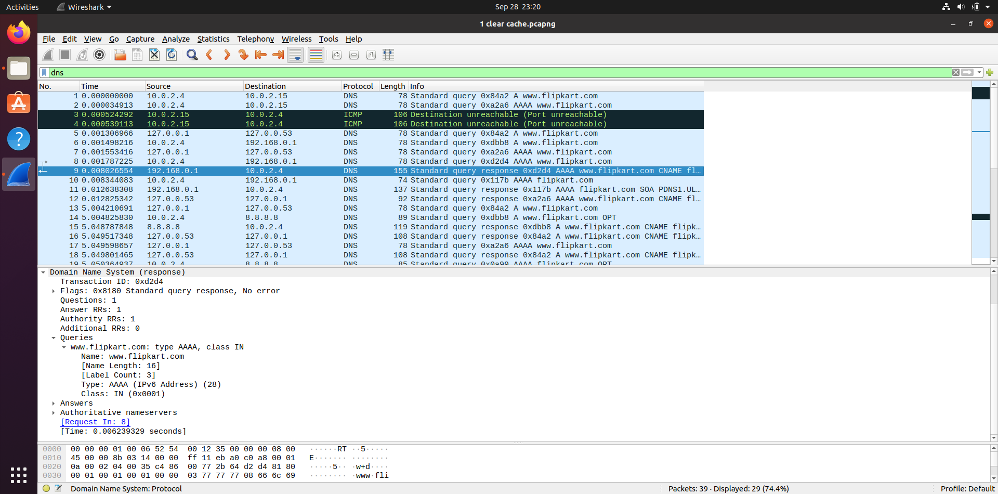

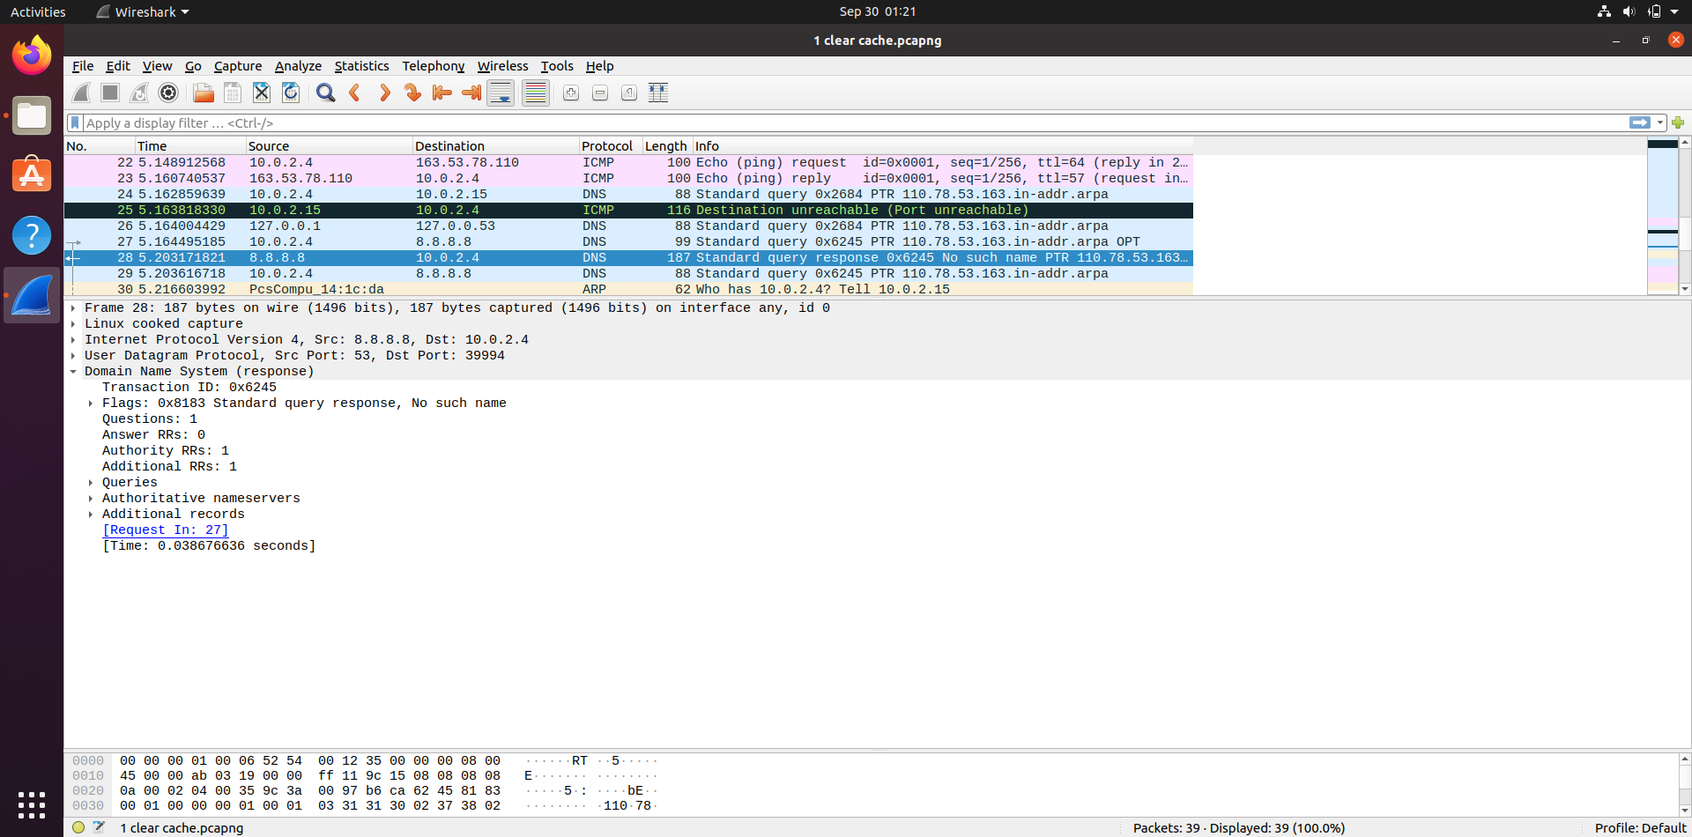

Observations: In this test, the request is sent to the local DNS (the IP address we set: 10.0.2.15) instead of the ISP. Since the server VM is not yet configured we get an ICMP error message saying that the port is unreachable. The request is then sent by the client VM to ISP for domain name resolution.

1) Locate the DNS query and response messages. Are then sent over UDP or TCP?

They are sent over UDP.

2) What is the destination port for the DNS query message? What is the source port of DNS response message?

Destination Port for DNS query message: 53

Source Port for DNS response message: 53

3) To what IP address is the DNS query message sent? Use ipconfig to determine the IP address of your local DNS server. Are these two IP addresses the same?

The query message is sent to 10.0.2.15. Because the port was unreachable, it was sent from 10.0.2.4 to 192.168.0.1 which is the client’s local DNS.



4) Examine the DNS query message. What “Type” of DNS query is it? Does the query message contain any “answers”?

The query highlighted in the first screenshot is a Type A Standard Query which stores hostname and its corresponding IPv4 address.

The query highlighted in the second screenshot shows Type AAAA Standard Query which stores hostname and its corresponding IPv6 address.

In the third query screenshot, we can also see one PTR query message that resolves an IP address to a domain or host name, unlike an A record which points a domain name to an IP address.

The query messages do not contain any answers.

5) Examine the DNS response message. How many “answers” are provided? What do each of these answers contain?

2 answers are provided in the response message for the A type query. 1 answer is provided for type AAAA and none for the PTR type. The format is the same as in the first test.

6) Consider the subsequent TCP SYN packet sent by your host. Does the destination IP address of the SYN packet correspond to any of the IP addresses provided in the DNS response message?

Output similar to that of first test.

**Task 2: Set Up a Local DNS Server**

**Third Test:**

Queries-

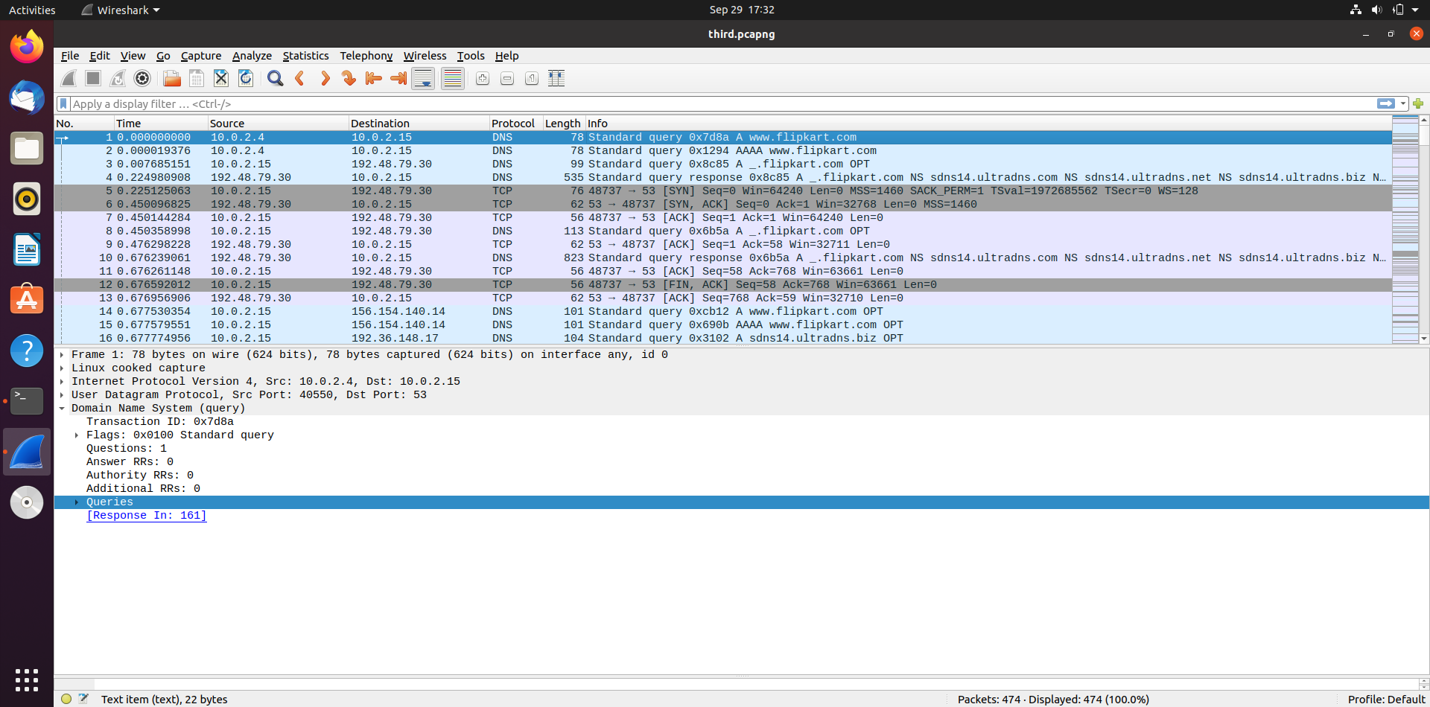

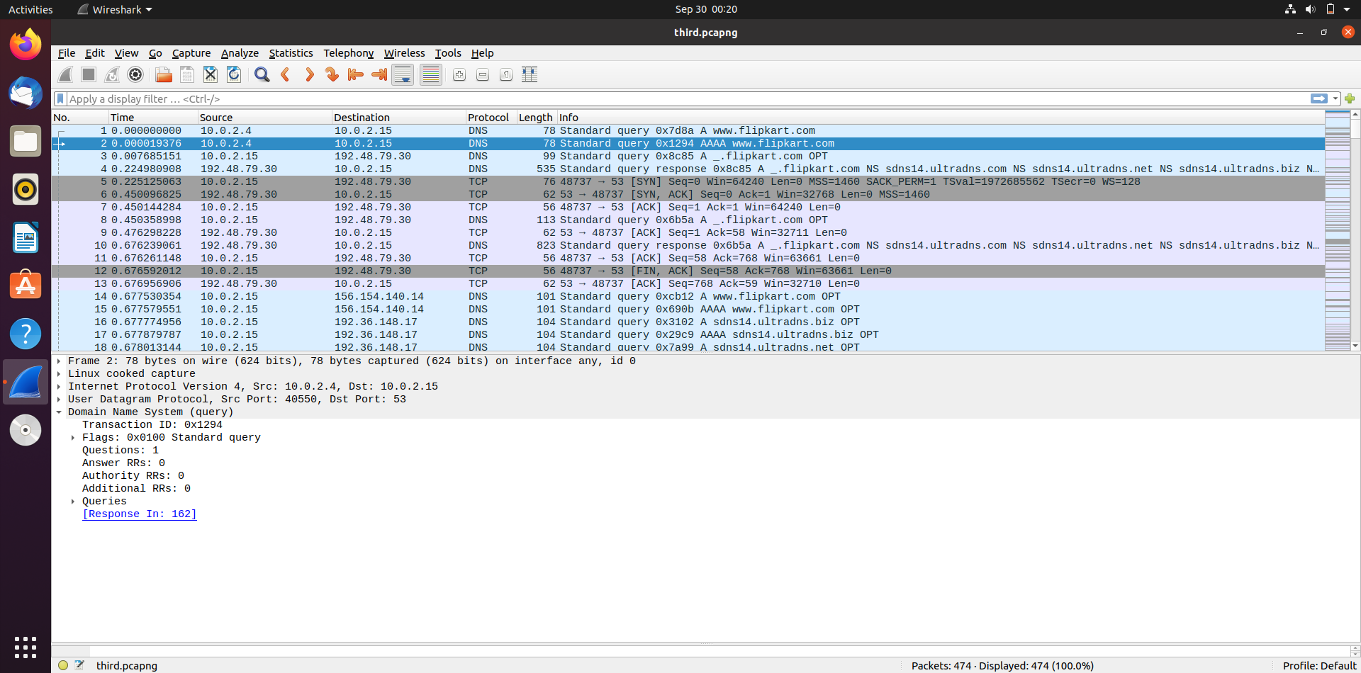

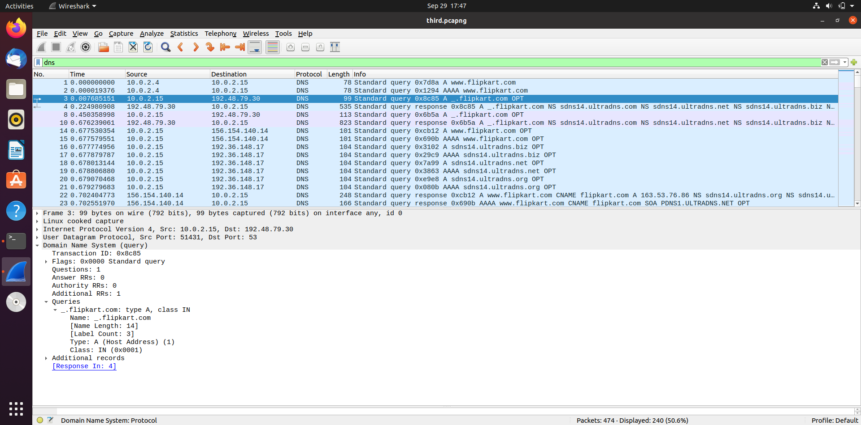

Responses-

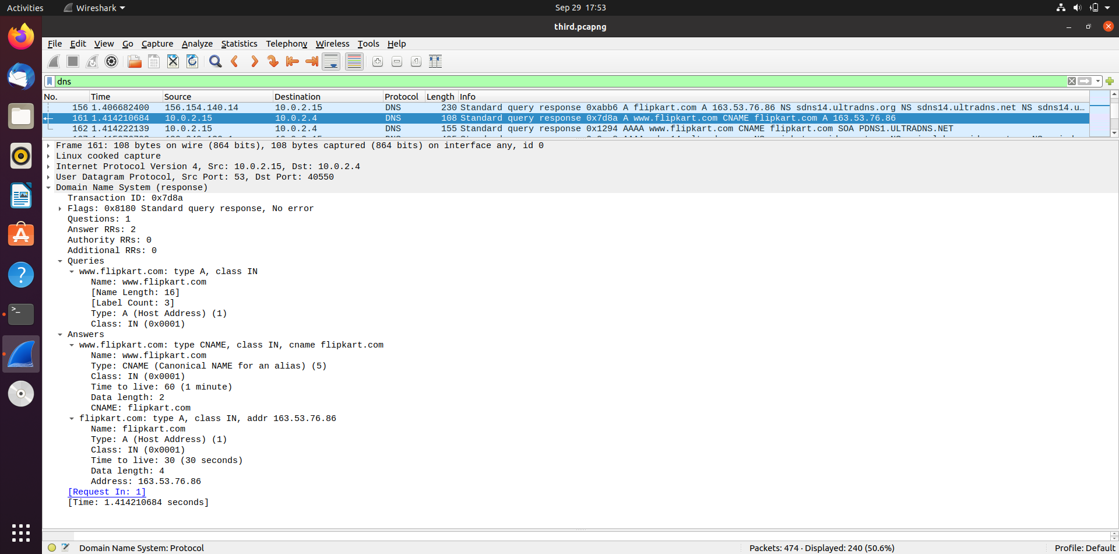

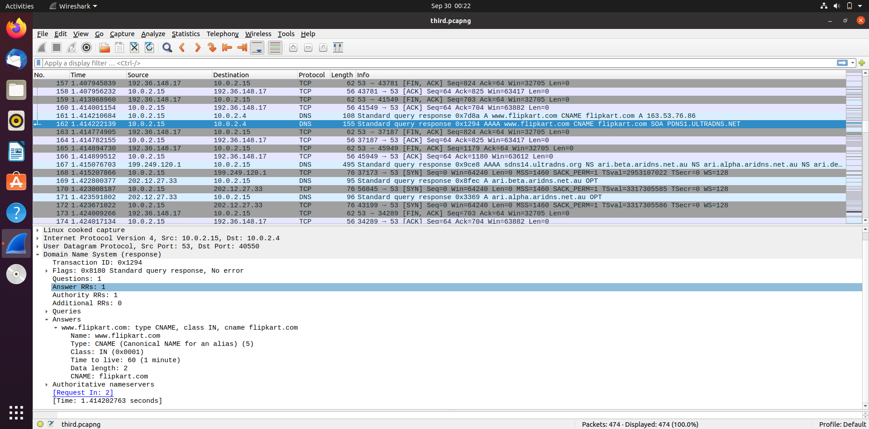

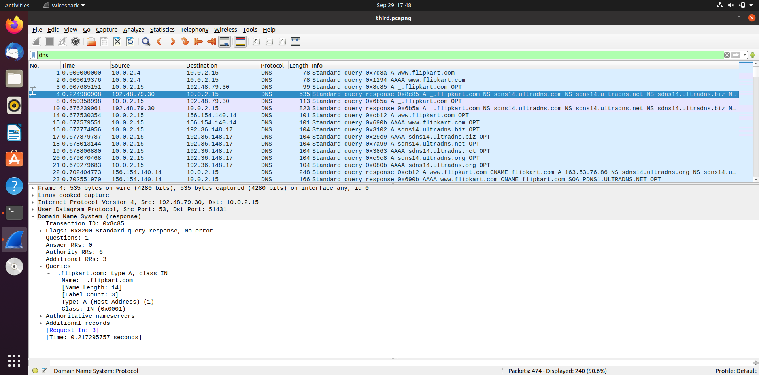

Cache-

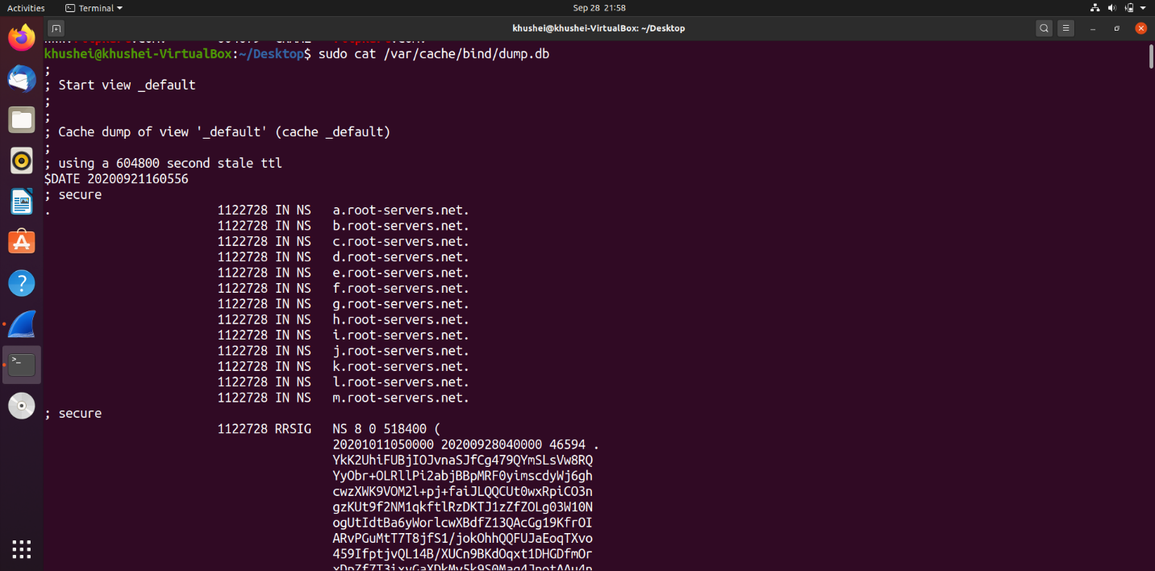

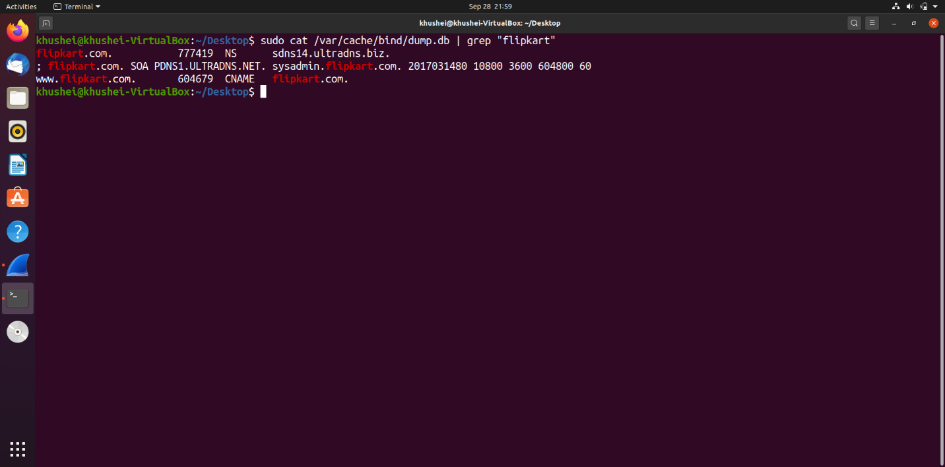

Observations: Since the local DNS with IP address 10.0.2.15 is set up and configured, the IP address of [www.flipkart.com](http://www.flipkart.com) is fetched from the local DNS itself. When the cache is cleared on server and we ping from the client, the first wireshark capture has the entire trace which is being cached, as shown above.

1) Locate the DNS query and response messages. Are then sent over UDP or TCP?

They are sent over UDP.

2) What is the destination port for the DNS query message? What is the source port of DNS response message?

Destination Port for DNS query message: 53

Source Port for DNS response message: 53

3) To what IP address is the DNS query message sent? Use ipconfig to determine the IP address of your local DNS server. Are these two IP addresses the same?

The query message is sent to 10.0.2.15.

From the server machine, again a query is made to 156.154.140.14 which is flipkart.com’s name server. 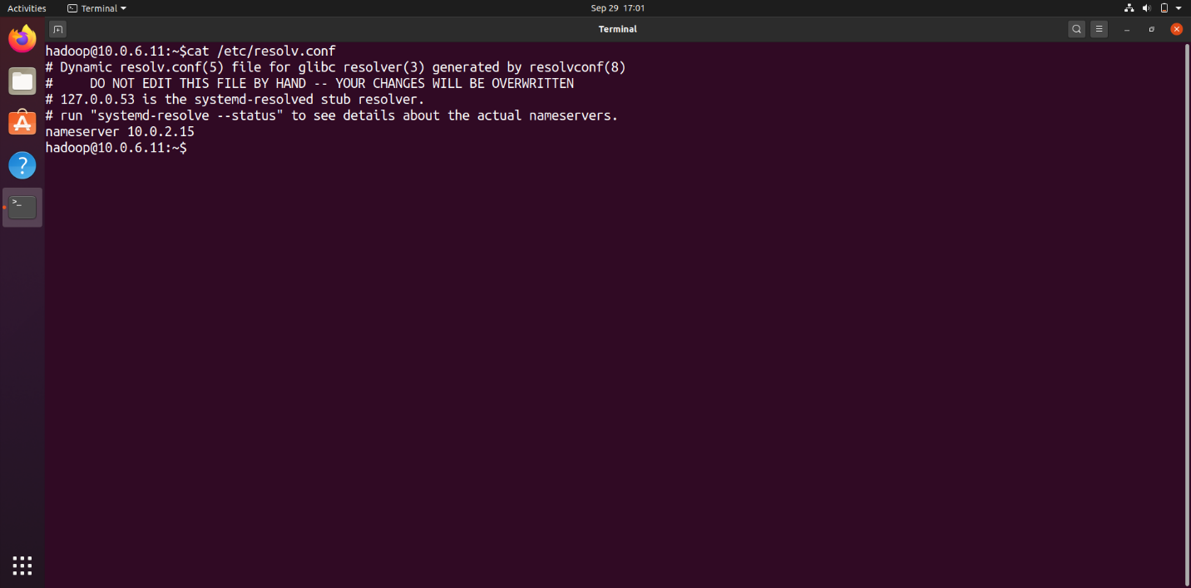

4) Examine the DNS query message. What “Type” of DNS query is it? Does the query message contain any “answers”?

The query highlighted in the first screenshot is a Type A Standard.

The next screenshot shows Type AAAA Standard Query.

The query messages do not contain any answers.

5) Examine the DNS response message. How many “answers” are provided? What do each of these answers contain?

2 answers are provided in the response message for the A type query. 1 answer is provided in the response message for the AAAA type query. The format is same as that of the first test.

6) Consider the subsequent TCP SYN packet sent by your host. Does the destination IP address of the SYN packet correspond to any of the IP addresses provided in the DNS response message?

The destination IP address is shown as 192.48.79.30.

No, the destination IP address does not correspond to any of the IP addressed provided in the DNS response message.

**Task 4: Restart the BIND server and test**

